Yield Spread Tracker
Research Query: Do changes in international government bond yields (GBY) forecast changes in the respective countries’ FX rates?
Methodology: Leveraged Python and FRED data to create a program that receives a request from the user for 2 country’s GBYs and calculates the spread. The program then compares the spread and compares it to 7-day average to calculate a Z-Score. This is done so that a statistically significant deviation as represented by a Z-Score of greater than or equal to $±2σ$triggers an alert. (Z-Score = $\frac{(x-μ)}{σ}$, $x:Current Yield Spread, μ:7-Day Moving Average, σ:7-Day Standard Deviation$).
Architecture: $engine.py→input.py→broker.py→maths.py→engine.py→terminal output$
- Engine file: performs and manages the requests from the input, broker and maths files
- Input file: allows the user to input two supported countries
- Broker file: fetches the appropriate data from the FRED api
- Maths file: calculates the yield spread and the 7-day Z-Score
I have isolated the different tasks for this program into separate files in order to have a modular architecture that can then also be scaled smoothly. It also makes debugging the program smoother since issues in the program can easily be pin-pointed to specific tasks and thus specific files.
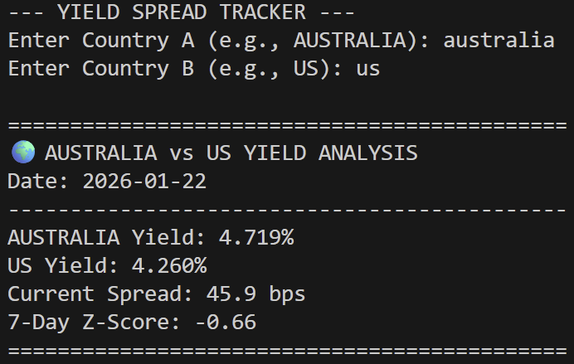
Terminal Output:

Finding: Inconclusive presently as the 7-Day Z-Score has not deviated significantly enough to warrant having a look at the USD/AUD charts to try and identify a discrepancy.
Reflection: While the 7-day Z-score is helpful for spotting immediate shocks, I’m concerned it might be too sensitive to daily 'noise' in the bond market. I’m considering testing a 21-day window to see if it provides a clearer macro signal, as a 21-day window represents roughly one business month providing a more stable $μ$ value.

